SYSTEM ADMINISTRATION AND MAINTENANCE
GUIDED STUDENT LABORATORY WORKSHEET
Advanced Administration: Process, Service, Log Management, and Troubleshooting

Student Information | Details
Name | MIke Phaul G. Banderada
Course / Year / Section | BSCS4
Instructor
Date Performed
Partner (if any)

Laboratory Overview
Operating systems: Windows 10/11 and Ubuntu Linux. Complete each lab on both systems where the required tools are available. Use a lab computer or virtual machine, not a production computer. Record observations and attach clear screenshots.
Lab | Topic | Real-world situation | Main outcome
1 | Process Management | A computer becomes slow while multiple applications are open. | Identify processes and inspect CPU/memory use.
2 | Service Management | Printing, remote access, or a website service stops working. | Inspect service state and perform an authorized service operation.
3 | Log Management | A user reports an error or a service fails. | Locate and interpret system/application events.
4 | Troubleshooting Methodology | A website or application is unavailable. | Use evidence to diagnose, verify, and document a fix.

Learning Objectives
- Use Windows PowerShell/Task Manager and Ubuntu Terminal to inspect running processes.
- Distinguish a service's current state from its startup configuration.
- Find relevant entries in Windows Event Viewer and the Ubuntu system journal.
- Apply a structured troubleshooting method: identify, theorize, test, plan, implement, verify, and document.
- Capture evidence, explain command output, and follow safe administration practices.

Safety Precautions — Read Before Starting
- Use an instructor-approved lab machine or disposable virtual machine. Do not practice on a production server or shared computer without permission.
- Do not terminate unfamiliar processes or critical system processes. Use the provided Notepad and sleep test processes only.
- Restarting Print Spooler may interrupt print jobs. Perform that step only with instructor approval and when no one depends on the service.
- Installing or enabling SSH changes the machine's remote-access exposure. Only do this in an authorized lab VM; stop/restore it as directed by the instructor.
- Do not intentionally generate real failed logins, security alerts, or service outages on shared or production systems.
- Do not change IP addresses, DNS, firewall, or service configurations unless authorized. Record the original state before making changes.
- Use placeholders such as <PID> only after replacing them with the actual process ID. Never type angle-bracket placeholders literally.
- Do not include passwords, personal data, public IPs, or other sensitive information in screenshots.

Required Tools
Windows 10/11 | Ubuntu Linux
Task Manager; PowerShell; Event Viewer (eventvwr.msc); Command Prompt. | Terminal; systemctl; journalctl; ps; top; logger; optional Nginx for Lab 4.

LAB 1 — PROCESS MANAGEMENT
Real-world scenario: The laboratory computer is slow. The administrator must identify resource-heavy processes before deciding what to do.

Objective
Inspect processes, compare CPU and memory information, and safely create and terminate a test process.

A. Windows 10/11 — Step by Step
- Press Ctrl + Shift + Esc to open Task Manager. Select Processes and observe CPU, Memory, Disk, and Network.
- Open PowerShell. Administrator privileges are not required for the inspection commands below.
Get-Process
Output & Interpretation
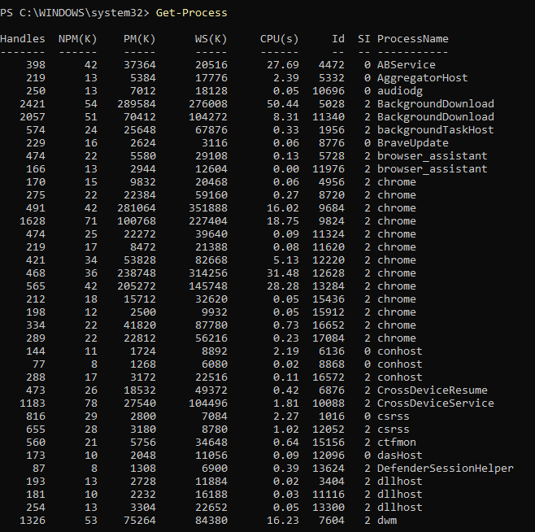
Interpretation:
I ran the `Get-Process` command in my PowerShell terminal to see what was eating up my system resources. I noticed a ton of Chrome tabs open, with one taking up over 350 MB of my RAM all on its own. On top of that, a `BackgroundDownload` task has been hogging my CPU, piling up over 50 seconds of processor time.

Get-Process | Sort-Object CPU -Descending | Select-Object -First 10 Name, Id, CPU
Output & Interpretation
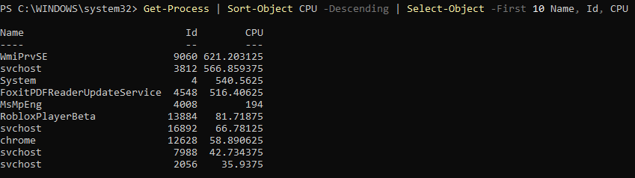
Interpretation:
I sorted my processes by CPU usage to see what's heavy on my system, and `WmiPrvSE` is topping the list with over 621 seconds of processor time. System background services like `svchost` and `System` are taking up a huge chunk right behind it, along with `FoxitPDFReaderUpdateService` sitting at over 516 seconds. Games like `RobloxPlayerBeta` and my `chrome` browser are actually using way less CPU than these background update services right now.

Get-Process | Sort-Object WorkingSet64 -Descending | Select-Object -First 10 Name, Id,
@{Name='MemoryMB';Expression={[math]::Round($_.WorkingSet64 / 1MB, 2)}}
Output & Interpretation
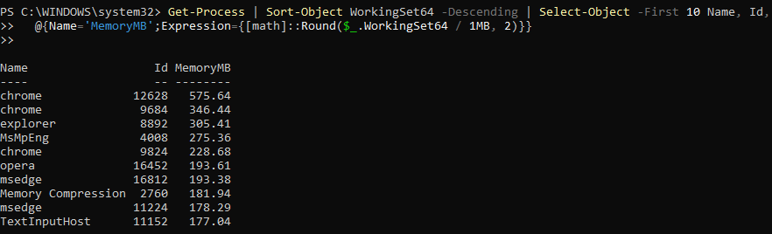
Interpretation:
I sorted my processes by memory usage this time to see what's eating up my RAM, and `chrome` is taking the top spot with one process using over 575 MB. Web browsers are definitely holding onto a lot of memory overall, since other Chrome tabs along with `opera` and `msedge` are all hovering between 178 MB and 346 MB. Right in the middle of all those browsers, standard system processes like `explorer`, `MsMpEng` (Windows Defender), and `Memory Compression` are each taking up around 180 MB to 305 MB of RAM.

3. Start and inspect a safe test process:
Start-Process notepad.exe
Output & Interpretation
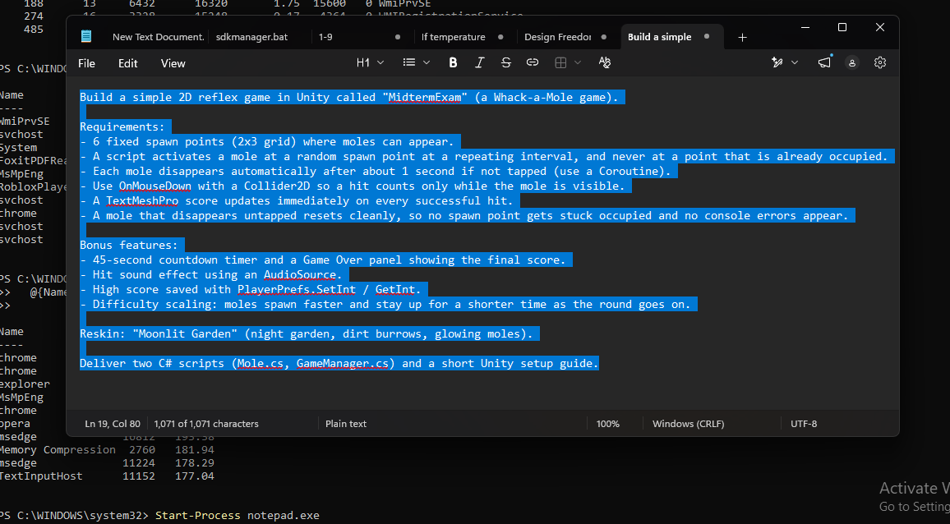
Interpretation:
I opened Notepad from PowerShell, and it pulled up my text file where I have all the requirements for a Unity 2D Whack-a-Mole midterm project laid out. It shows everything I need to build—from the 2x3 grid and mole spawn logic to the 45-second timer, high scores, and sound effects—all wrapped in a "Moonlit Garden" theme. It even lists the exact deliverables needed: the `Mole.cs` and `GameManager.cs` scripts along with a setup guide.

Get-Process notepad
Output & Interpretation
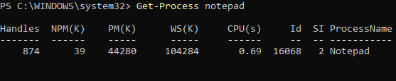
Interpretation:
Notepad is running just fine (process ID 16068), using about 100 MB of working memory and barely any CPU, so nothing's wrong with it.

- Close Notepad normally. Re-run Get-Process notepad to verify it has exited. If instructor-approved process termination is demonstrated, reopen Notepad, note its PID, then run:

Output & Interpretation

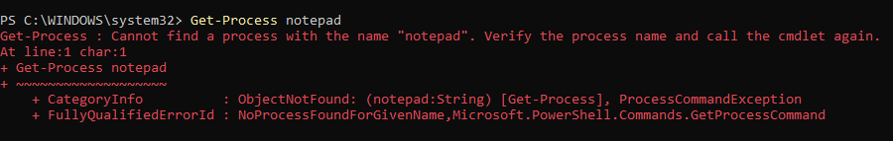
Interpretation:
PowerShell can't find a Notepad process this time, which just means Notepad isn't running anymore (you probably closed it).
top

Output & Interpretation
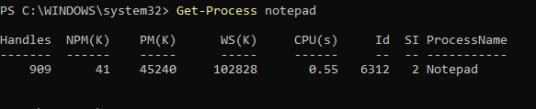
Interpretation:
Notepad is running again with a new process ID (6312), still using around 100 MB of memory and almost no CPU, so it's just a fresh instance you reopened.

Replace <PID> with the actual numeric ID. Do not stop unfamiliar processes.

B. Ubuntu Linux — Step by Step
- Open Terminal with Ctrl + Alt + T.
- Run the following commands. Press q to exit top.
Top
Output & Interpretation
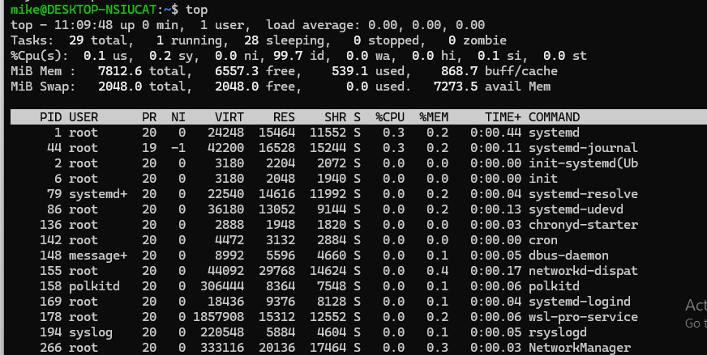
Interpretation:
This Linux system (looks like WSL) just booted and is basically idle: 99.7% of the CPU is free, only about 539 MB of the 7.8 GB of RAM is in use, and the 29 tasks are mostly standard background services like systemd and networking.

ps aux
Output & Interpretation
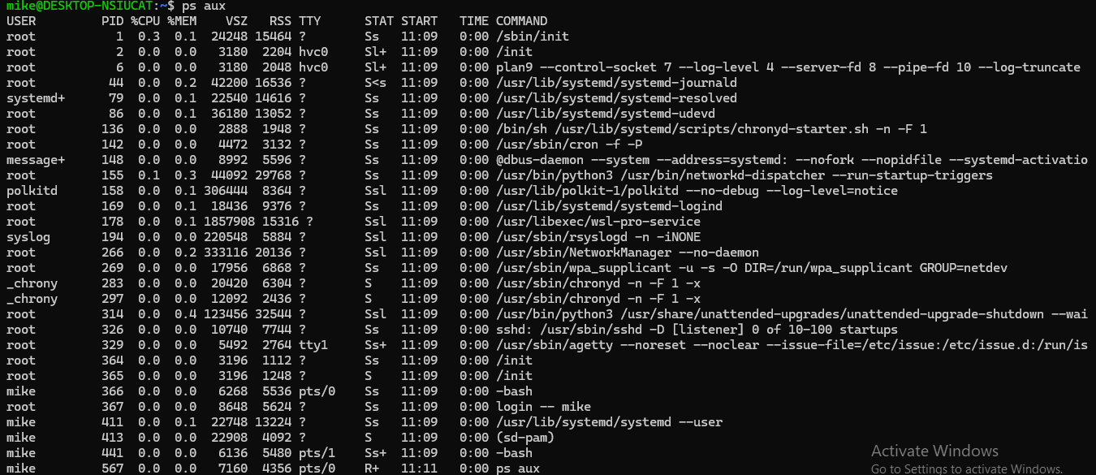
Interpretation:
This is a fresh WSL Linux session where everything is idle (all 0.0% CPU), made up of normal background services like systemd, networking, and ssh, plus your own bash shells and the `ps aux` command you just ran.

ps -eo pid,comm,%cpu,%mem --sort=-%cpu | head -n 11
Output & Interpretation
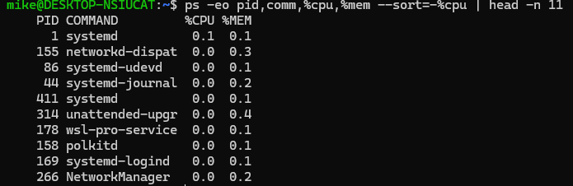
Interpretation:
This lists your top processes sorted by CPU use, and even the busiest ones (systemd at 0.1% and networkd-dispatcher at 0.0%) are basically idle, with memory use all under 0.5%, so nothing is hogging your system.

3. Create a harmless background test process and display its PID:
sleep 300 &
Output & Interpretation
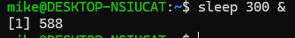
Interpretation:
You just started a `sleep 300` command in the background (the `&` does that), and the shell is telling you it's job number 1 with process ID 588, which will quietly do nothing for 5 minutes and then exit.

echo $!
Output & Interpretation
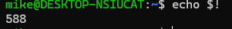
Interpretation:
`$!` holds the process ID of the last background job you started, so it printed 588, which matches the `sleep 300 &` from before.

ps -p $! -o pid,stat,cmd
Output & Interpretation
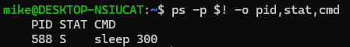

Interpretation:
I’m checking on that background job by its PID, and it shows `sleep 300` (PID 588) still alive with a status of `S`, meaning it's just sleeping and waiting out its 5 minutes.

4. Copy the PID printed by echo $! and terminate only this test process:
kill <PID>
Output & Interpretation

Interpretation:
I ran `kill 588` to stop the background `sleep 300`, and the shell confirmed it by printing "Terminated" for job [1], so my sleep command got cut off before its 5 minutes were up.

ps -p <PID>
Output & Interpretation
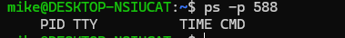
Interpretation:
I checked on PID 588 after killing it, and `ps` came back with just the column headers and no rows, so the process is really gone.

No output from the final command means the process is no longer listed. Replace <PID> with the actual number.

Record Your Observations
OS | Process name | PID | CPU / memory observation | What did you learn?
Windows | Notepad | 16068 | ~0.69 CPU(s) and ~100 MB working set; reopened instance ~0.55 CPU(s) and ~100 MB | Get-Process shows a process’s PID, memory, and CPU time. It errors once Notepad is closed, and reopening gives a new PID.
Ubuntu | sleep 300 | 588 | 0.0% CPU and under 0.5% memory for nearly all processes; system 99.7% idle with ~539 MB of 7.8 GB RAM used | ps and top list processes and their resource use. I can start a background job with &, find its PID with $!, stop it with kill 588, and confirm it’s gone when ps -p returns nothing.

Lab 1 Guide Questions
- Why is it important to identify a process before terminating it?
- Killing the wrong process can crash applications, cause data loss, or even destabilize the whole system if it’s something critical like a system service. Identifying it first (by name, PID, and what it’s doing) makes sure you only stop the one you actually mean to.

- What is the difference between CPU time and current CPU utilization?
- CPU time is the total amount of processor time a process has used since it started (like the CPU(s) column in Get-Process), so it only goes up. Current CPU utilization is the percentage of the processor the process is using right now (like %CPU in top), so it rises and falls with activity.

- What does a PID represent?
- A PID (process ID) is a unique number the operating system assigns to each running process so it can track and manage it. Commands like kill and ps -p use the PID to target a specific process, and it changes each time a process is restarted (like Notepad going from 16068 to 6312).

- Why is a controlled test process safer than stopping an unknown system process?
- A test process like sleep 300 or Notepad is one you started yourself, so you know exactly what it does and that stopping it has no side effects. An unknown system process might be doing something essential, so terminating it could break services or crash the system.

LAB 2 — SERVICE MANAGEMENT
Real-world scenario: Printing stops working or a web/remote-access service is unavailable. The administrator checks service state before making changes.

Objective
Inspect service status and startup settings, perform only an authorized operation, and verify the result.

A. Windows 10/11 — Step by Step
- Press Windows + R, type services.msc, and press Enter.
Output & Interpretation
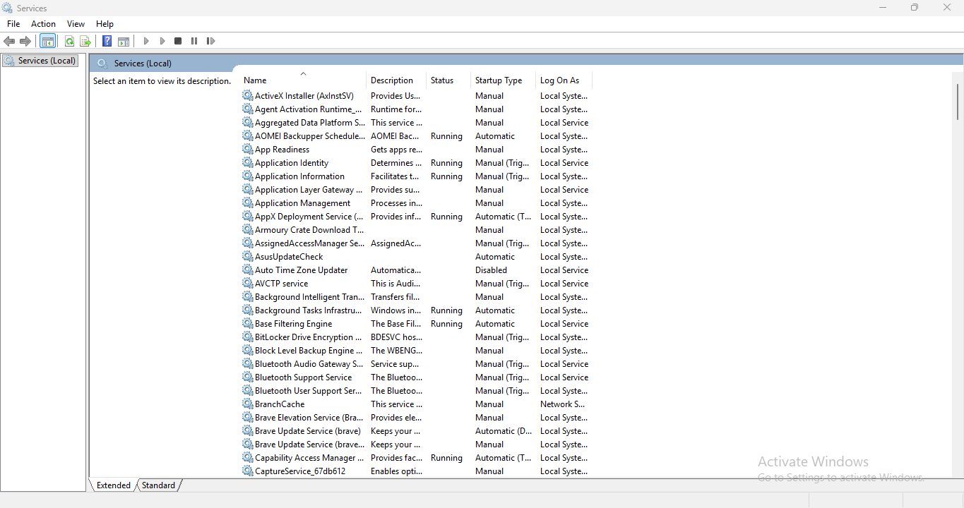
Interpretation:
I opened the Services console with Windows + R and `services.msc`, and it shows me all the background services on my PC along with which ones are running, how they start up (Automatic, Manual, or Disabled), and what account they run under.

- Locate Print Spooler. Observe its Status and Startup Type. Do not change the startup type.
Output & Interpretation
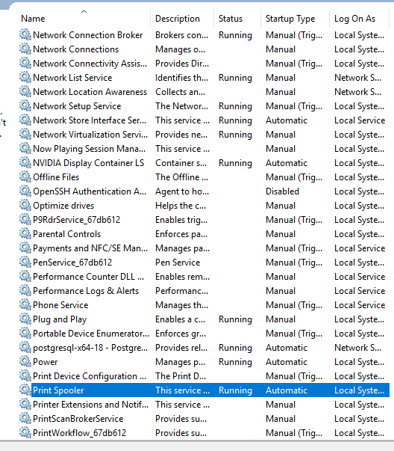

Interpretation:
I scrolled down to Print Spooler and selected it, and it's currently Running with an Automatic startup type under Local System, so it starts on its own every time my PC boots.

- Open PowerShell and run:
Get-Service -Name Spooler
Output & Interpretation
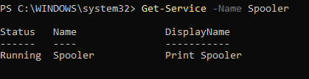
Interpretation:
I ran `Get-Service -Name Spooler` in PowerShell, and it confirms the Print Spooler service is Running, matching what I saw in the Services window.

Get-CimInstance Win32_Service -Filter "Name='Spooler'" | Select-Object Name, State, StartMode
Output & Interpretation
Interpretation:
I ran a `Get-CimInstance Win32_Service` query for Spooler, and it shows the service is Running with a StartMode of Auto, which gives me the same answer as the Services window plus the startup type in one line.

4. If the instructor authorizes it, and no print jobs/users depend on the service, restart it from an elevated PowerShell window:
Restart-Service -Name Spooler
Output & Interpretation
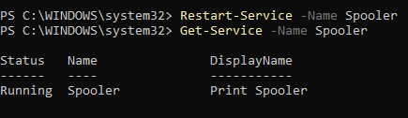

Get-Service -Name Spooler
Interpretation:
I ran `Restart-Service -Name Spooler` and then checked it with `Get-Service`, and the Print Spooler is back to Running, so the restart went through without any errors.

B. Ubuntu Linux — Step by Step
- Open Terminal.
- Inspect SSH service status and startup configuration:
systemctl status ssh
Output & Interpretation
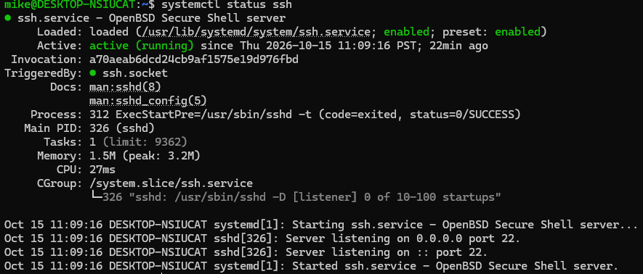
Interpretation:
I ran `systemctl status ssh` on my Ubuntu side, and it shows the SSH server is active (running) and enabled to start at boot, listening on port 22 since 11:09 with only 1.5 MB of memory and barely any CPU used.

systemctl is-active ssh
Output & Interpretation
Interpretation:
I ran `systemctl is-active ssh` and it just answered "active," which is a quick yes that the SSH service is running.

systemctl is-enabled ssh
Interpretation:
I ran `systemctl is-enabled ssh` and it answered "enabled," which means the SSH service is set to start automatically every time this system boots.

3. If SSH is not installed, skip installation unless the instructor approves it. In an authorized lab VM only, installation can be performed with:
sudo apt update
Output & Interpretation

sudo apt install openssh-server
Output & Interpretation

4. Start the service and inspect its status:
sudo systemctl start ssh
Output & Interpretation
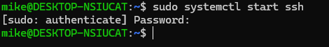

Interpretation:
I ran `sudo systemctl start ssh` and it's now asking for my password, since starting a service needs admin rights, so I just have to type it in (it won't show anything as I type) and hit Enter.

systemctl status ssh
Output & Interpretation
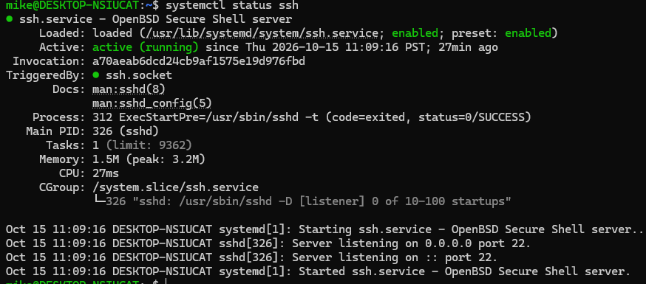
Interpretation:
I checked `systemctl status ssh` again after trying to start it, and it's still active (running) and enabled, with the same start time of 11:09 and now 27 minutes up, so the start command didn't need to do anything since SSH was already running.

5. Enabling the service at boot is optional and must be instructor-approved:
sudo systemctl enable ssh
Output & Interpretation
Interpretation:
I ran `sudo systemctl enable ssh`, and it synced the SSH service with its SysV script and ran the `systemd-sysv-install enable ssh` command, which just makes sure SSH is set to start at boot (it already was, so nothing really changed).

6. In an isolated lab VM, students may stop SSH if authorized, check the state, and then restore it if needed:
sudo systemctl stop ssh
Output & Interpretation
Interpretation:
I ran `sudo systemctl stop ssh` and it stopped the SSH service, but it warned me that `ssh.socket` is still active, which means the socket can quietly start SSH back up the moment someone tries to connect to port 22.

systemctl is-active ssh
Output & Interpretation
Interpretation:
I ran `systemctl is-active ssh` again and it now says "inactive," so the stop command worked and the SSH service is no longer running (though the socket could still bring it back if something connects to port 22).

sudo systemctl start ssh
Output & Interpretation
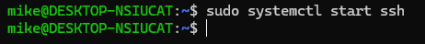
Interpretation:
I ran `sudo systemctl start ssh` again and it finished without printing anything, which is how Linux says it worked, so SSH should be running again (I can confirm with `systemctl is-active ssh`).

Record Your Observations
OS / service | Initial state | Action taken (or skipped) | Final state | Reason / result
Windows / Spooler | Running, Automatic startup | Restarted it with Restart-Service -Name Spooler | Running | Restarting a service is a safe way to refresh it. It came back up with no errors, and Get-Service confirmed it was Running.
Ubuntu / SSH | Active (running) and enabled | Stopped it with sudo systemctl stop ssh, then started it again with sudo systemctl start ssh. enable was already set, so it changed nothing. | Active (running) and enabled. I’d run systemctl is-active ssh once more to confirm it says “active” before you write this. | The stop showed “inactive,” and the start brought it back. Stopping it triggered a warning that ssh.socket could still restart SSH when something connects to port 22.

Lab 2 Guide Questions
- What is the difference between a service's current state and its startup configuration?
- The current state is what the service is doing right now (Running or Stopped, or active/inactive in Linux). The startup configuration is what it will do at boot (Automatic, Manual, or Disabled in Windows, enabled/disabled in Linux). In your lab, SSH was active and enabled, and when you stopped it, its state changed to inactive but it stayed enabled, so it would still start on the next boot.

- Why might restarting a service interrupt other users?
- A restart briefly stops the service before starting it again, so anything connected to it gets dropped. Restarting Print Spooler can cancel or stall print jobs in progress, and restarting SSH can cut off remote sessions that other users or admins are working in.

- Why should SSH only be installed or enabled in an authorized environment?
- SSH opens a remote login path into the machine (port 22), so if it’s running where it shouldn’t be, it gives attackers a door to try brute-force logins or exploit weak passwords. Running it only where it’s approved means it can be properly secured, monitored, and kept inside the organization’s security policy.

- If a service is running but the application still fails, what else should be investigated?
The service being up doesn’t mean everything around it works. I’d check:
- The application’s and service’s logs for errors (Event Viewer on Windows, journalctl on Linux)
- Network issues, like firewall rules, blocked ports, or the service listening on the wrong address
- Permissions and the account the service runs under
- Configuration files and any recent changes
- Dependencies, such as a database or another service the app needs
- Resource limits like disk space, memory, or CPU

LAB 3 — LOG MANAGEMENT
Real-world scenario: A user reports an error or a service fails. The administrator uses timestamps and messages to investigate what happened.

Objective
Find log entries, record useful event details, and distinguish an error from a warning or informational event.

A. Windows 10/11 — Step by Step
- Press Windows + R, type eventvwr.msc, and press Enter.
Output & Interpretation
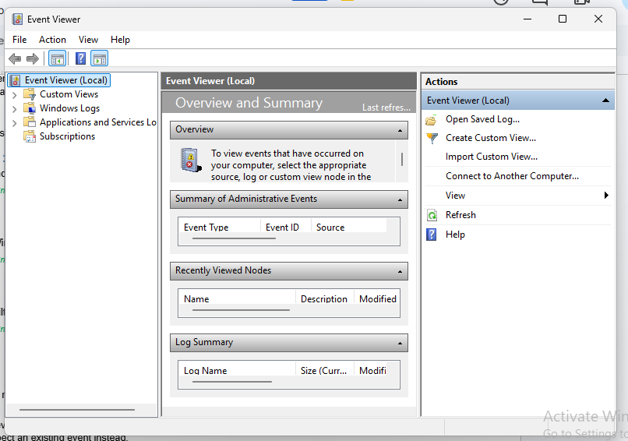
Interpretation:
I opened Event Viewer, and right now it's just showing the overview and summary page, which is the starting point for digging into Windows Logs (like Application, Security, and System) to see what events have been recorded on my PC.

- Expand Windows Logs and select System.
Output & Interpretation
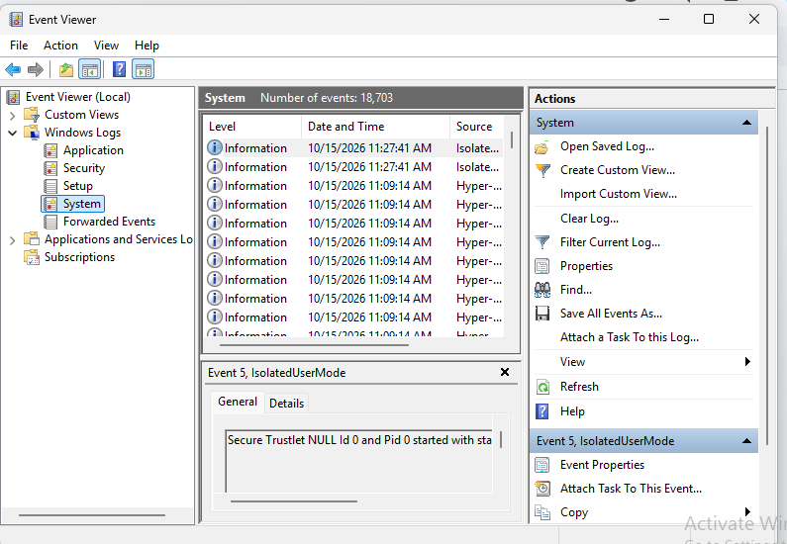

Interpretation:
I opened the System log under Windows Logs, and it has 18,703 events, with the newest ones being harmless Information entries from IsolatedUserMode and Hyper-V sources, including Event 5 about a Secure Trustlet starting up.

- Choose Filter Current Log and select Error and Warning levels. Apply the filter.
Output & Interpretation
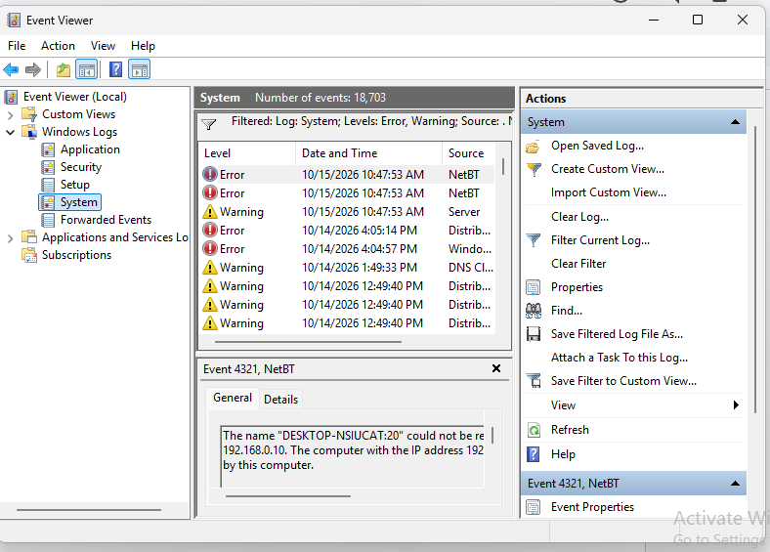

Interpretation:
I filtered the System log down to just Errors and Warnings, and the newest ones are NetBT errors (Event 4321) saying my computer's name couldn't be registered on the network because another device at 192.168.0.10 already has it, plus some DNS and Distributed COM warnings from the past couple of days.

- Open one relevant event and record its source, Event ID, date/time, and General description.
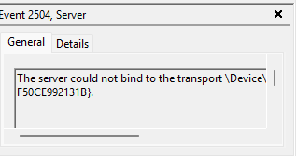

Optional test event: in PowerShell, run the command below if event creation is allowed by the lab policy. If unavailable or restricted, inspect an existing event instead.
eventcreate /T INFORMATION /ID 100 /L APPLICATION /SO "SystemAdminLab" /D "Lab test event for log management."
Output & Interpretation
Interpretation:
I ran `eventcreate` in an admin PowerShell this time, and it worked: it wrote an Information event with ID 100 into the Application log under the source "SystemAdminLab," so I should be able to find it in Event Viewer.

Return to Windows Logs > Application and look for source SystemAdminLab, Event ID 100.
Output & Interpretation
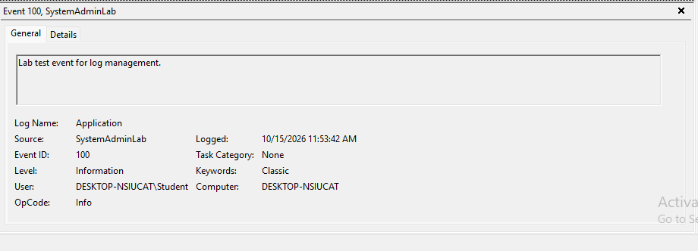
Interpretation:
I found the event I created in Event Viewer: Event 100 from "SystemAdminLab" in the Application log, logged at 11:53:42 AM as an Information-level entry with the message "Lab test event for log management," so the `eventcreate` command worked.
Optional PowerShell view of recent System events:
Get-WinEvent -LogName System -MaxEvents 10 |
Select-Object TimeCreated, Id, LevelDisplayName, Message

Output & Interpretation
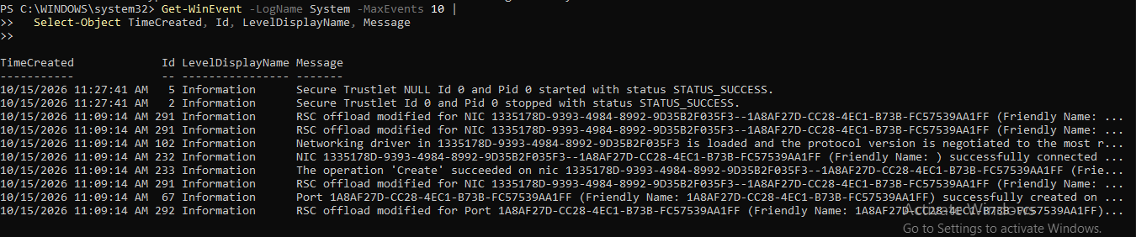
Interpretation:
I ran `Get-WinEvent` on the System log to pull the 10 newest events, and they're all harmless Information entries, mostly from 11:09 AM when the network adapter and virtual port were set up (RSC offload changes, the networking driver loading, the NIC connecting) plus the Secure Trustlet start and stop at 11:27 AM.

B. Ubuntu Linux — Step by Step
- Open Terminal.
- View recent system journal entries:
journalctl -n 20
Output & Interpretation
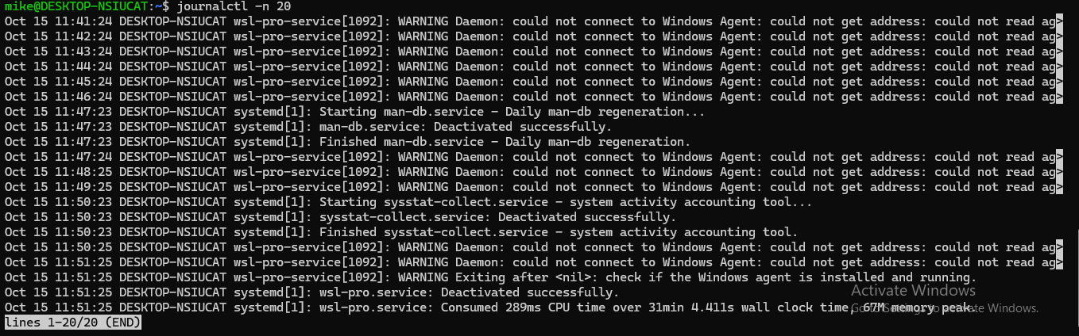
Interpretation:
I ran `journalctl -n 20` to see the last 20 log entries, and it's mostly `wsl-pro-service` warning once a minute that it can't connect to the Windows Agent (it finally gave up and exited at 11:51), mixed with routine systemd jobs like the daily man-db rebuild and the sysstat collector, so nothing is actually broken.

journalctl -p err -b
Output & Interpretation
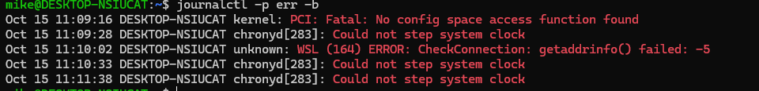
Interpretation:
I ran `journalctl -p err -b` to see only the errors from this boot, and there are just five: a PCI "no config space access function" message from the kernel, a WSL `getaddrinfo()` connection check failure, and chronyd repeatedly saying it couldn't step the system clock, which are all common, harmless noise in WSL since it's a virtualized environment.

journalctl -f
Output & Interpretation

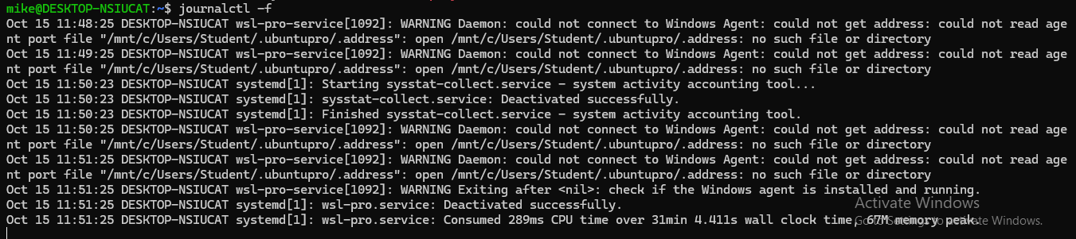
Interpretation:
I ran `journalctl -f` to follow the log live, and it's showing the same `wsl-pro-service` warnings about not finding the Windows Agent's address file (`.ubuntupro/.address`), ending with the service exiting at 11:51 and the cursor sitting there waiting for any new log lines to show up.

Press Ctrl + C to stop following live logs.
3. Inspect recent SSH service entries if SSH is installed:
sudo journalctl -u ssh -n 30 --no-pager
Output & Interpretation
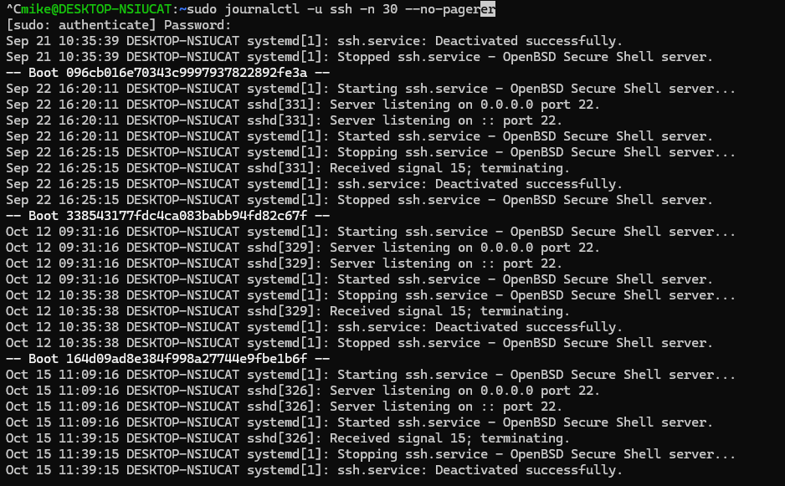
Interpretation:
I ran `sudo journalctl -u ssh -n 30 --no-pager` to see just the SSH service's history, and it shows the service starting and stopping across several boots (Sep 21, Sep 22, Oct 12, and today), including today's start at 11:09 listening on port 22 and a stop at 11:39 when it received signal 15, which was my `systemctl stop ssh` from earlier.

4. Generate a harmless test message:
logger "System Administration Lab: test log entry"

Output & Interpretation
Interpretation:
I ran `logger "System Administration Lab: test log entry"` and it finished without printing anything, which is normal, so my test message should now be sitting in the system log (I can find it with `journalctl -n 5` or `journalctl | grep "System Administration Lab"`).

5. Search recent journal entries and locate the test message:
journalctl -n 30 --no-pager
Output & Interpretation
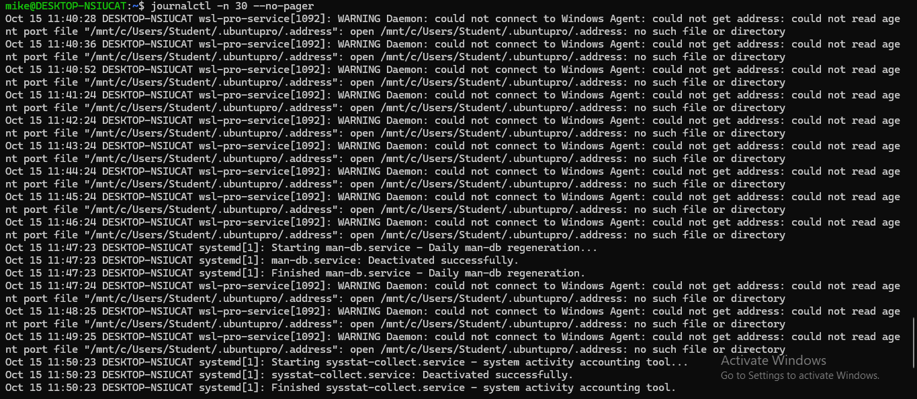

Interpretation:
I ran `journalctl -n 30 --no-pager` to see the last 30 log entries, but my `logger` test message isn't in there, since it just shows the repeating `wsl-pro-service` Windows Agent warnings and routine jobs like man-db and sysstat that end at 11:50, so I'll try `journalctl | grep "System Administration Lab"` to find it.

Expected Results
- Windows Event Viewer displays events with timestamps, sources, IDs, and descriptions.
- Ubuntu journalctl displays recent events and can filter by priority or service.
- Students explain the event's significance without assuming every warning is a security incident.

Record One Event
Field | Windows event | Ubuntu journal entry
Date/time | 10/15/2026 11:53:42 AM | Oct 15 11:39:15
Source / service | SystemAdminLab (Application log) | sshd[326] / systemd (ssh.service)
Event ID / message | Event ID 100: “Lab test event for log management.” | “Received signal 15; terminating.” followed by “Stopped ssh.service - OpenBSD Secure Shell server.”
Severity / priority | Information | Info (normal priority, not an error)
Interpretation and next step | This is the test event I created with eventcreate, which confirms I can write to and find entries in the Application log. Next step: filter by source or Event ID when looking for specific events, and use a real source for real troubleshooting. | This is the SSH service shutting down cleanly after my sudo systemctl stop ssh, since signal 15 is a normal termination request. Next step: confirm SSH is running again with systemctl is-active ssh, and use journalctl -u ssh to review its history.

Lab 3 Guide Questions
- How can a timestamp help an administrator diagnose an incident?
- A timestamp lets you line up events in order and see what happened right before a problem started. In your lab, the SSH stop at 11:39:15 matched the systemctl stop ssh you ran, and you can do the same across logs, like checking whether a service crash happened right after an update or a failed login. It also helps you spot patterns, like the wsl-pro-service warning repeating every minute.
- What is the difference between a warning and an error?
- A warning means something unexpected or potentially problematic happened, but the service or task kept working, while an error means something actually failed. In your logs, the DNS and Distributed COM entries were warnings, while the NetBT name registration failure and chronyd’s “Could not step system clock” were errors, since an operation didn’t complete.
- Why should a log entry be interpreted in context?
- A single line can look scary or harmless without the full picture. Your PCI “No config space access function” error looks serious, but it’s normal noise in WSL because it’s virtualized. Likewise, “Received signal 15; terminating” for SSH is normal when you stopped it yourself but would be suspicious if nobody did. Context means checking what else happened around that time, what changed recently, and whether the behavior is normal for that system.
- What additional evidence would you collect before concluding that an account or service was compromised?
A single suspicious entry isn’t proof, so I’d gather:
- Authentication logs, such as failed and successful logins, logins from unusual IPs or at odd hours (Security log on Windows, /var/log/auth.log or journalctl -u ssh on Linux)
- Recent account changes, like new users, privilege changes, or password resets
- Unexpected processes, services, scheduled tasks, or startup entries
- Network connections and open ports that shouldn’t be there
- Changes to important files or configs, checked against a known-good baseline or file hashes
- Antivirus or EDR alerts and timeline correlation across multiple systems
- Confirmation from the user or owner about whether the activity was expected

LAB 4 — TROUBLESHOOTING METHODOLOGY
Real-world scenario: A school website or application is unavailable. The administrator must determine whether the cause is local networking, DNS, a stopped service, configuration, or another dependency.

Objective
Apply a seven-step troubleshooting process and document the evidence, fix, and verification result.

Seven-Step Method
Step | What to do
1. Identify | Describe symptoms and scope; ask what changed.
2. Theory | List plausible causes before changing anything.
3. Test | Use commands and logs to collect evidence.
4. Plan | Choose a low-risk fix and note rollback steps.
5. Implement | Apply only an authorized correction.
6. Verify | Repeat the failing test and confirm normal operation.
7. Document | Record cause, evidence, fix, outcome, and prevention.

A. Windows 10/11 — Network Diagnostic
Scenario: A website will not open. Do not change network settings during this guided diagnostic.
ipconfig
ping 127.0.0.1
nslookup example.com
Test-NetConnection example.com -Port 443
Output & Interpretation
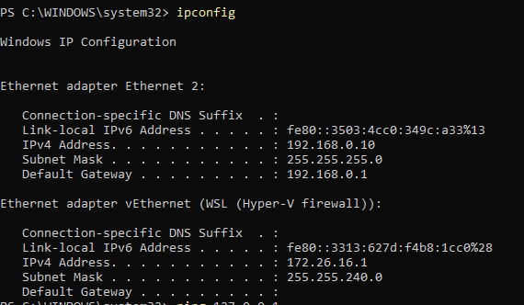

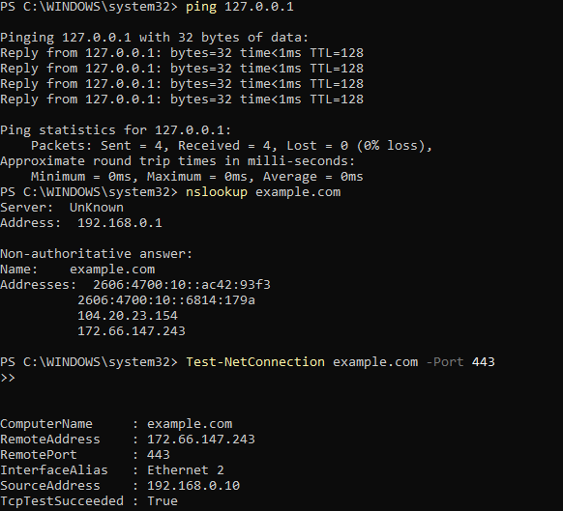
Interpretation:
I pinged 127.0.0.1 and got all 4 replies back instantly with 0% loss, so my network stack is working, then `nslookup` resolved example.com through my router (192.168.0.1) to a few IPv4 and IPv6 addresses, and `Test-NetConnection` on port 443 came back `TcpTestSucceeded : True`, so I can actually reach example.com over HTTPS from my PC (192.168.0.10).

B. Ubuntu Linux — Network and Web-Service Diagnostic
Step 1: inspect local network configuration and name resolution:
ip addr
ip route
ping -c 4 127.0.0.1
getent hosts example.com
Output & Interpretation
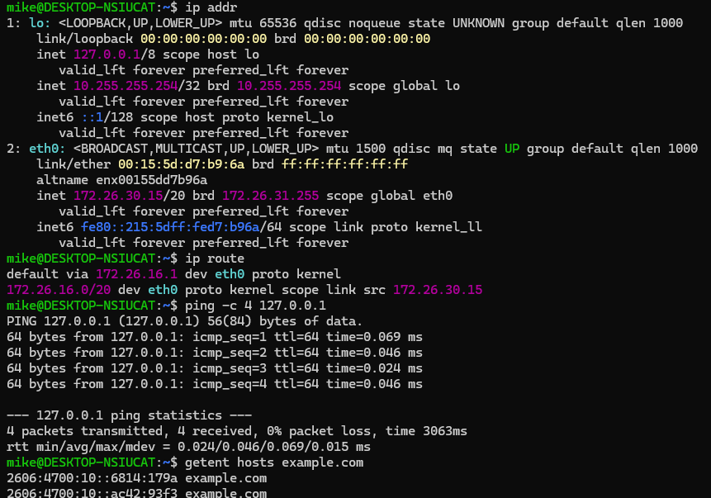

Interpretation:
I ran `ip addr`, `ip route`, `ping`, and `getent hosts` in Ubuntu, and everything checks out: my `eth0` interface is up with IP 172.26.30.15, my default route goes out through the gateway at 172.26.16.1, the loopback ping got 4 of 4 replies with 0% loss, and `example.com` resolved to its IPv6 addresses, so my networking and DNS are working.

Step 2: if Nginx is installed in the lab VM, inspect it:
systemctl status nginx
Output & Interpretation

Step 3: if Nginx is installed, check its configuration:
sudo nginx -t
Output & Interpretation
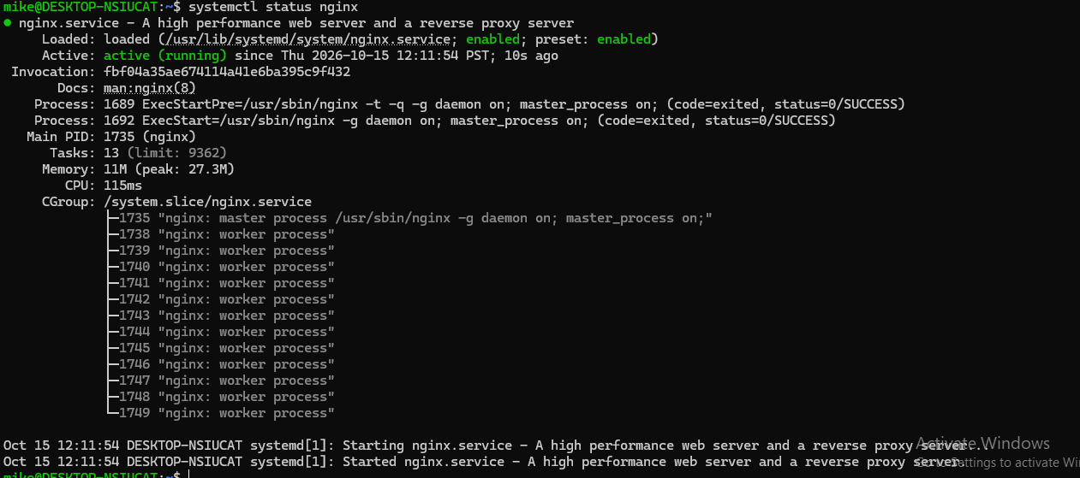
Interpretation:
I ran `systemctl status nginx` and nginx installed fine: it's active (running) and enabled to start at boot, started at 12:11:54 with one master process (PID 1735) and 12 worker processes, using only about 11 MB of memory.

Step 4: only if the instructor authorizes it and the service is simply stopped, start it:
sudo systemctl start nginx
Output & Interpretation

Interpretation:
I ran `sudo systemctl start nginx` and it finished without printing anything, which is normal and means it worked; nginx was already running, so the command didn't really change anything.

If configuration testing fails, inspect and correct the reported issue first; do not start/reload a broken configuration. If Nginx is not installed, record that and use the network diagnostic results instead.
Step 5: verify the local web response, if Nginx is installed and expected to serve HTTP:
systemctl status nginx
curl -I http://localhost
Output & Interpretation
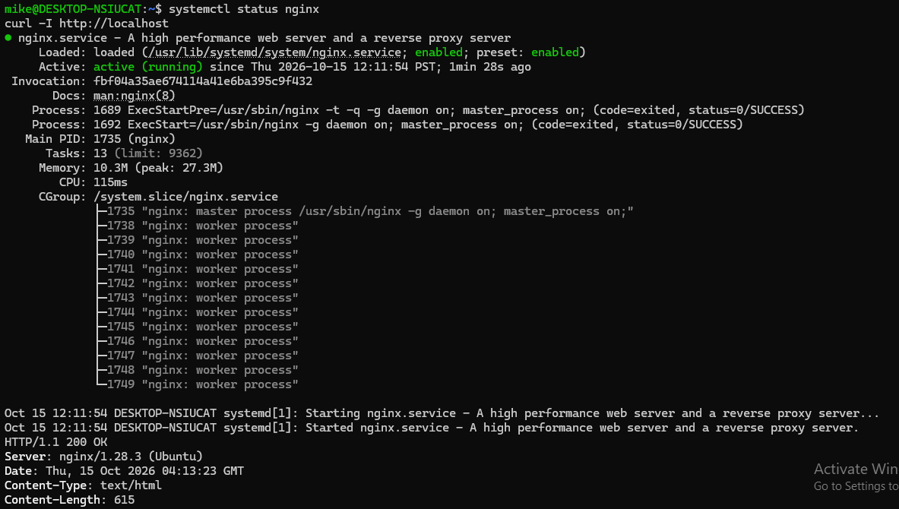
Interpretation:
I ran `systemctl status nginx` and then `curl -I http://localhost`, and nginx is active (running) for about 1.5 minutes and answered with `HTTP/1.1 200 OK` from nginx/1.28.3, so the web server is actually serving its default page on my machine, not just sitting there running.

Lab 4 Guide Questions
- Why should an administrator test a theory before applying a fix?
- A theory is only a guess until it’s confirmed, and applying a fix based on a wrong guess can waste time or make things worse. Testing it first, like checking whether DNS resolves before touching the firewall, narrows the problem down so you change only what’s actually broken.

- How do DNS failure and TCP port failure differ?
- A DNS failure means the name can’t be translated into an IP address, so you never even get to the server (for example, nslookup example.com fails). A TCP port failure means the name resolved fine, but the connection to that port is blocked or the service isn’t listening (for example, Test-NetConnection example.com -Port 443 returns TcpTestSucceeded : False). In your lab, nslookup returned addresses and port 443 succeeded, so both layers were healthy.

- Why should a configuration be validated before restarting a service?
- A restart with a broken config can leave the service down, and then everyone who depends on it loses access. Validating first catches typos and bad settings while the old, working service is still running. For nginx, you’d run sudo nginx -t and only restart if it says the syntax is OK.

- What evidence proves the fix worked?
- You need a test that shows the original problem is gone, not just a command that ran without errors. For example, the service shows active (running), the port responds, and the app works for the user. In your lab, curl -I http://localhost returning HTTP/1.1 200 OK proved nginx was serving pages. The logs should also stop showing the original error.
- Why should the troubleshooting process be documented?
- Notes let you or a teammate see what was tried, what changed, and why it worked, so the same problem can be fixed faster next time. They also help you undo a change if something breaks, give a record for audits or incident reviews, and make handoffs between admins smoother.

SCREENSHOT EVIDENCE CHECKLIST
Attach screenshots to this worksheet or submit them in the instructor's required format. Ensure text is readable and sensitive information is hidden.
Evidence ID | Required screenshot | Attached
1A | Windows Task Manager or Get-Process output showing process information | ☐
1B | Ubuntu top/ps output and test process verification | ☐
2A | Windows Print Spooler status and startup configuration | ☐
2B | Ubuntu SSH status and active/enabled check (or explain if unavailable) | ☐
3A | Windows Event Viewer event details or PowerShell event output | ☐
3B | Ubuntu journalctl output including the test log or relevant event | ☐
4A | Windows network diagnostic output | ☐
4B | Ubuntu network diagnostic and, if available, Nginx verification | ☐

